1. Create a basic webpage layout using HTML and CSS, following semantic HTML principles. Your layout should include the following sections:
   1. Header
   2. Navigation
   3. Main Content Area
   4. Footer

**Task#1:**

* Index.html

|  |
| --- |
| **<!DOCTYPE html>**  **<html lang="en">**  **<head>**  **<meta charset="UTF-8">**  **<meta name="viewport" content="width=device-width, initial-scale=1.0">**  **<title>Basic Webpage Layout</title>**  **<style>**  **body {**  **font-family: Arial, sans-serif;**  **margin: 0;**  **padding: 0;**  **line-height: 1.6;**  **}**  **header {**  **background: #333;**  **color: #fff;**  **padding: 1rem 0;**  **text-align: center;**  **}**  **nav {**  **background: #555;**  **color: #fff;**  **padding: 0.5rem;**  **text-align: center;**  **}**  **nav a {**  **color: #fff;**  **margin: 0 1rem;**  **text-decoration: none;**  **}**  **main {**  **padding: 1rem;**  **}**  **footer {**  **background: #333;**  **color: #fff;**  **text-align: center;**  **padding: 1rem 0;**  **position: relative;**  **bottom: 0;**  **width: 100%;**  **}**  **</style>**  **</head>**  **<body>**  **<header>**  **<h1>Welcome to My Website</h1>**  **</header>**  **<nav>**  **<a href="#home">Home</a>**  **<a href="#about">About</a>**  **<a href="#contact">Contact</a>**  **</nav>**  **<main>**  **<h2>Main Content Area</h2>**  **<p>This is where the main content of the webpage will go.</p>**  **</main>**  **<footer>**  **<p>&copy; 2023 My Website</p>**  **</footer>**  **</body>**  **</html>** |

**Output:**

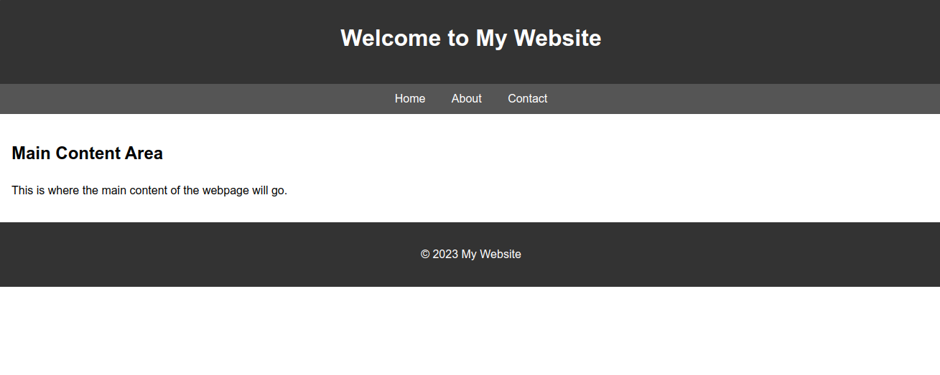

2. Create your Time Table. Attached the output and the code

**Task#2:**

* **Index.html**

|  |
| --- |
| **<!DOCTYPE html>**  **<html lang="en">**  **<head>**  **<meta charset="UTF-8">**  **<meta name="viewport" content="width=device-width, initial-scale=1.0">**  **<title>Abdullah Mohsin Portfolio</title>**  **<style>**  **body {**  **font-family: Arial, sans-serif;**  **margin: 0;**  **padding: 0;**  **line-height: 1.6;**  **}**  **header {**  **background: #333;**  **color: #fff;**  **padding: 1rem 0;**  **text-align: center;**  **}**  **header h1 {**  **margin: 0;**  **}**  **main {**  **padding: 2rem;**  **}**  **.project {**  **margin-bottom: 1.5rem;**  **}**  **footer {**  **background: #333;**  **color: #fff;**  **text-align: center;**  **padding: 1rem 0;**  **position: fixed;**  **bottom: 0;**  **width: 100%;**  **}**  **.skills {**  **margin-top: 1.5rem;**  **}**  **</style>**  **</head>**  **<body>**  **<header>**  **<h1>Abdullah Mohsin</h1>**  **<p>B.Tech Software | Language: German | 4th Semester</p>**  **</header>**  **<main>**  **<section>**  **<h2>About Me</h2>**  **<p>Hello! I am Abdullah Mohsin, a passionate programmer skilled in Flutter, C++, Java, Python, and Machine Learning.</p>**  **</section>**  **<section class="skills">**  **<h2>Skills</h2>**  **<ul>**  **<li>Flutter</li>**  **<li>C++</li>**  **<li>Java</li>**  **<li>Python</li>**  **<li>Machine Learning</li>**  **</ul>**  **</section>**  **<section>**  **<h2>Projects</h2>**  **<div class="project">**  **<h3>Project 1</h3>**  **<p>Description of the project goes here.</p>**  **</div>**  **<div class="project">**  **<h3>Project 2</h3>**  **<p>Description of the project goes here.</p>**  **</div>**  **</section>**  **</main>**  **<footer>**  **<p>&copy; 2023 Abdullah Mohsin. All rights reserved.</p>**  **</footer>**  **</body>**  **</html>** |

**Output:**

